Riga Technical University

FACULTY OF COMPUTER SCIENCE AND INFORMATION TECHNOLOGY

Fundamentals of Computer Graphics and Image Processing

Practical Work #2

The second practical work - Ellipse line algorithm

FCSIT
International Student
Said Naghiyev
Stud. ID Nr. 201ADB100

Task of Work
Contains the task of work

Programming Code
Contains the programming code of the program

Screen Shots
Contains screen shots that prove the correct work of the program

Task of Work

Once you have completed the Ellipse line midpoint algorithm, and you can draw a complete ellipse, you will need to draw a binary representation of the last 3 digits of your student id using Ellipses.
The "1" should be represented by a filled ellipse, and "0" by an empty ellipse.
For example: if your student id is (200RDB154) then you need to draw 154 which in binary is 1001 1010. And the final result should look like an image bellow.
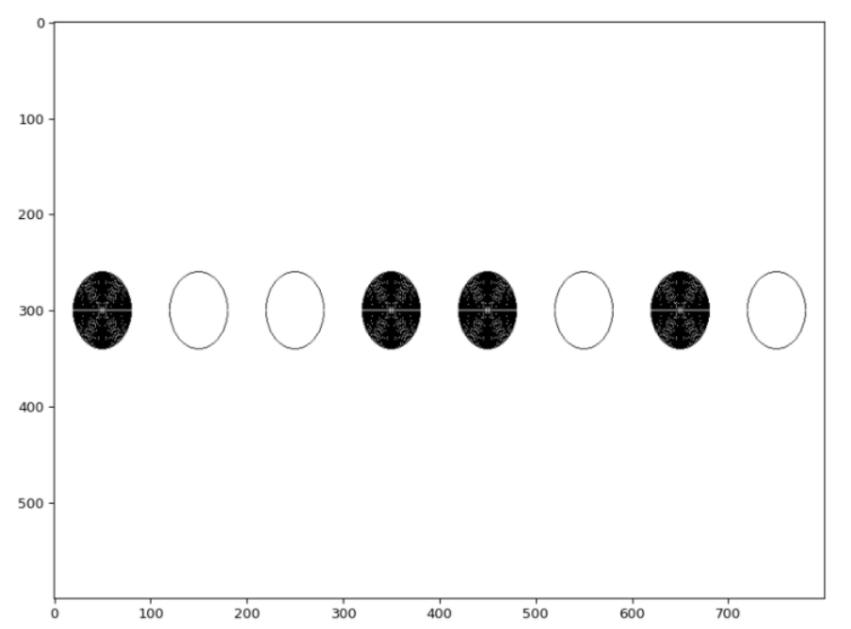

Programming Code
import numpy as np
import matplotlib.pyplot as plt
from matplotlib.patches import Ellipse
import math

img = np.ones((250,900,3))
def Fill(x,y):#before I tried use Filling until boundary but it is so heavy
if((x>0 and x<890) and (y>0 and y<249) and img[x,y,0] != 0.0):
img[x,y] = 0;
Fill(x,y+1);
Fill(x,y-1);
Fill(x+1,y);
Fill(x-1,y);
else:
print(x,y);

def DrawEllipse(xc, yc, rx, ry):
xk = 0;
yk = ry;
pk = ry*ry-rx*rx*ry + (1/4)*rx*rx;

while(ry*ry*xk < rx*rx*yk):
xk+=1;
if(pk>0):
yk-=1;
pk=pk+2*ry**2*xk-2*rx**2*yk+ry**2;
else:
pk=pk+2*ry**2*xk+ry**2;

img[(xc+xk), (yc+yk)] = 0;
img[(xc+xk), (yc-yk)] = 0;
img[(xc-xk), (yc+yk)] = 0;
img[(xc-xk), (yc-yk)] = 0;

pk = ry*ry*(xk+(1/2))*(xk+(1/2))+rx*rx*(yk-1)*(yk-1)-ry*ry*rx*rx;

while(yk>0):
yk-=1;
if(pk<0):
xk+=1;
#pk=pk-2*ry*ry*yk+2*ry*ry*yk+rx*rx;
pk=pk-2*rx*rx*yk+rx*rx+2*ry*ry*xk;
else:
#pk=pk-2*rx*rx*yk+rx*rx;
pk=pk-2*rx*rx*yk+rx*rx;
img[(xc+xk), (yc+yk)] = 0;
img[(xc+xk), (yc-yk)] = 0;
img[(xc-xk), (yc+yk)] = 0;
img[(xc-xk), (yc-yk)] = 0;
return;
#0110 0100
ID = "01100100"; #//Enter You id here or whatever you want with byte
posy = 100;
posx = 50;
num = 0;

for i in ID:
DrawEllipse(posy,posx, 49, 36);
if(i=='1'):
xx = 49;
while(xx>=0):
DrawEllipse(posy,posx, xx, 36);
xx-=1;
posx+=80;

plt.figure(figsize = (10,8), dpi=100,facecolor = 'w', edgecolor='k');
plt.imshow(img);
plt.show();

